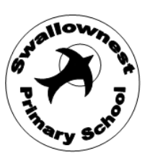

Swallownest Primary Admissions Arrangements Consultation 2025/2026:
Swallownest Primary School wishes to consult with you on their current admissions arrangements.
No changes have been made to these arrangements, however, it is a requirement as outlined in ‘The School Admissions Code 2021’ that all admission authorities must consult on their admission arrangements at least once every 7 years, even when no changes have been made to the arrangements.
The consultation period is to span over a minimum of 6 weeks. For Swallownest Primary School, we intend to consult from Thursday 14th December 2023.
This consultation is applicable to: -
- parents/carers of children between the ages of 3 and 11 who attend SWP.
- other persons in the relevant geographical area who, in the opinion of the admissions authority, have an interest in the proposed admissions arrangements.
- to all other admission authorities within the relevant area.
- to the local authority
- to any neighbouring local authorities where the admission authority is the local authority
- in the case of schools designated with a religious character, the body or person representing the religion or religious denomination
All SWP admissions arrangements can be read following the link to the SWP website and searching the folder in the parent and carers drop down box (policies).
https://www.swallownestprimary.org
If you wish to raise any points about our admission arrangements then please email us at: - enquiries@swallonestprimaryschool.org
Following the 6-week consultation period, any arrangements and accompanying feedback will be taken to the Local Schools Board Body and Trust Board meetings in February 2024. On agreement by governors, the arrangements will be published on the School website and then sent to the relevant local authority prior to their publication date of 15th March 2024.
Thank you for taking the time to support our consultation.

