THE DIOCESE OF SHEFFIELD ACADEMIES TRUST



**SWALLOWNEST PRIMARY SCHOOL**

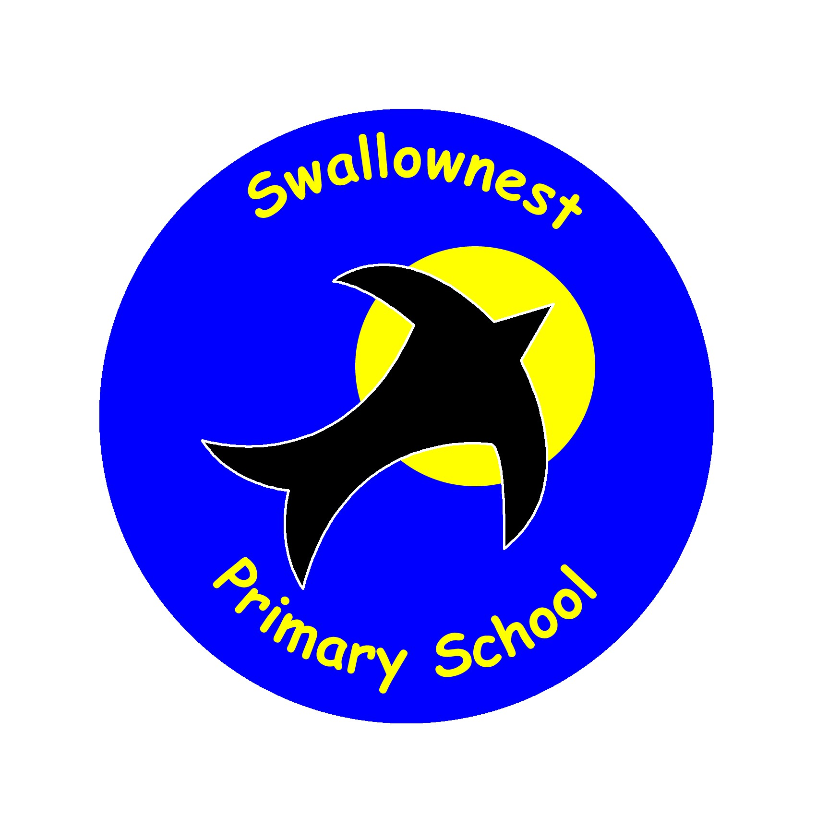

**SEND Information Report and Policy**

**2024-25**

SENDCo: Mrs Sian Leivers

Exceutive Headteacher: Mr Leyton Mchale

Head of School: Mrs Emily Peake

Contact: Sian Leivers 0114 2872484

senco@swn.dsat.education

Local Offer Contribution: <http://www.rotherhamsendlocaloffer.org.uk/>

B**ackground Information 2024-25**

Here at Swallownest Primary school, “***We want the best for and the best from everyone in our learning community***”. This means that we have highest aspirations and expectations for **all** of the children in our school. Children with additional needs are fully integrated into all aspects of school life and enjoy the same opportunities as their peers. We are proud of our inclusive ethos and we are committed to meeting the needs of children with SEND, working collaboratively with parents/carers, the pupil and external agencies, where appropriate.

1. **The aims of our provision in regard to children with SEN and/or a Disability**

The aims of our policy and practice in relation to special educational need and disability in this school are:

* To ensure that children and young people with SEN engage in all activities of the school, alongside pupils who do not have SEN.
* To request, monitor and respond to parent/carers’ and children’s views in order to evidence high levels of confidence and partnership.
* To ensure a high level of staff expertise to meet pupil need, through continuing professional development.
* To support pupils with medical conditions to achieve full inclusion in all school activities by ensuring consultation with health and social care professionals and staff training in order to meet the medical needs of pupils.
* To work in cooperative and productive partnership with the Local Authority and other outside agencies, to ensure there is a multi-professional approach to meeting the needs of all vulnerable learners.

‘*Swallownest Primary School is a warm and welcoming school.* ***Leaders do all they can to help pupils be successfu*l**.’

OFSTED, March 2023

1. **Legislation and Guidance**

This policy and information report is based on the statutory [Special Educational Needs and Disability (SEND) Code of Practice](https://www.gov.uk/government/uploads/system/uploads/attachment_data/file/398815/SEND_Code_of_Practice_January_2015.pdf) and the following legislation:

* [Part 3 of the Children and Families Act 2014](http://www.legislation.gov.uk/ukpga/2014/6/part/3), which sets out schools’ responsibilities for pupils with SEN and disabilities
* [The Special Educational Needs and Disability Regulations 2014](http://www.legislation.gov.uk/uksi/2014/1530/contents/made), which set out schools’ responsibilities for education, health and care (EHC) plans, SEN co-ordinators (SENCOs) and the SEN information report

1. **Definitions**

At Swallownest Primary, we use the definition for SEN and for disability from the SEND Code of Practice (2014). This states:

* ‘A child or young person has SEN if they have a learning difficulty or disability, which calls for special educational provision to be made for him or her.’ (Department for Education, 2014, xiii, SEND Code of Practice: 0-25 years)
* *A child of compulsory school age or a young person has a learning difficulty or disability if he or she:*

- ***has a significantly greater difficulty in learning than the majority of others of the same age****, or*

- *has a disability which* ***prevents or hinders him or her from making use of facilities of a kind generally provided for others of the same age in mainstream schools*** *or mainstream post-16 institutions*

1. **Roles and Responsibilities**

Our SENDCo is Mrs Sian Leivers**.** It is the SENDCo’s responsibility to:

* work with the headteacher, executive headteacher and governing body to determine the strategic development of the SEN policy and provision in the school, through regular and effective self-evaluation
* have day-to-day responsibility for the operation of this SEN policy and the co-ordination of specific provision made to support individual pupils with SEN, including those who have EHC plans
* provide professional guidance to colleagues and work with staff, parents, and other agencies to ensure that pupils with SEN receive appropriate support and high-quality teaching
* advise on the graduated approach to providing SEN support
* be the point of contact for external agencies, especially the local authority and its support services
* liaise with potential next providers of education to ensure that the school meets its responsibilities under the Equality Act 2010, with regard to effective transition, reasonable adjustments and access arrangements
* ensure the school keeps the records of all pupils with SEN up to date

The Exceutive Headteacher is Mr Leyton Mchale and the Head of School is Mrs Emily Peake. The headteacher/s will:

* work with the SENCO and SEN governor to determine the strategic development of the SEN policy and provision within the school, through regular and effective self-evaluation
* have overall responsibility for the provision and progress of learners with SEN and/or a disability

The Chair of Governors is Carl Maw. The Chair of Governors, alongside the governing body will:

* monitor the quality and effectiveness of SEN and disability provision within the school, by ensuring the curriculum is well led, effectively managed and well planned
* work with the headteacher and SENCO to determine and evaluate the strategic development of the SEN policy and provision in the school, through regular and effective self-evaluation
* ensure all pupils make progress in achieving the expected educational outcomes

Each class teacher is responsible for:

* the progress and development of every pupil in their class
* working closely with any teaching assistants or specialist staff to plan and assess the impact of support and interventions and how they can be linked to classroom teaching
* working with the SENCO to review each pupil’s progress and development and decide on any changes to provision
* ensuring they follow this SEN policy

‘*Leaders quickly identify the individual support pupils with special educational needs and/or disabilities. This ensures that staff understand accurately the needs of pupils with SEND.* ***SEND pupils achieve well***.’

OFSTED, March 2023

1. **What kinds of Special Educational Needs might the children at Swallownest Primary School have?**

In the SEND code of practice there are four broad areas of need:

* **Communicating and Interacting:** this relates to children who have speech, language and communication difficulties which makes it hard for them to make sense of language or communicate with others.
* **Cognition and Learning:** this relates to children who learn at a slower pace to others their age, have difficulty understanding aspects of the curriculum, struggle with organisation and memory skills or have a specific barrier to learning which affects their progress in one aspect of their learning, such as English or Maths.
* **Social, Emotional and Mental Health Difficulties:** this relates to children who have difficulties in forming and managing relationships with others, children who are withdrawn or who display behaviour which has a negative impact on their learning or on their emotional health and wellbeing.
* **Sensory and/ or Physical needs:** this relates to children who have visual or hearing impairments, or a physical need which means that they will require additional and ongoing support and resources to access the curriculum and the learning environment.

Our school currently provides additional and/or different provision for a range of needs, including:

* Communication and interaction, for example, speech and language difficulties
* Cognition and learning, for example, Dyslexia, Moderate learning difficulties
* Social, emotional and mental health difficulties, for example, Attention Deficit Hyperactivity Disorder (ADHD), Autistic Spectrum Condition
* Sensory and/or physical needs, for example, hearing impairments, processing difficulties, visual impairment

1. **How does our school identify children and young people with SEND needs?**

‘*High quality teaching, differentiated for individual pupils, is the first step in responding to pupils who have or may have SEN. Additional intervention and support cannot compensate for a lack of good quality teaching*’

Department for Education, 2014, 6.37, SEND Code of Practice: 0-25 years

Our school follows a process called the **Graduated Response.** This incorporates three stages of support:

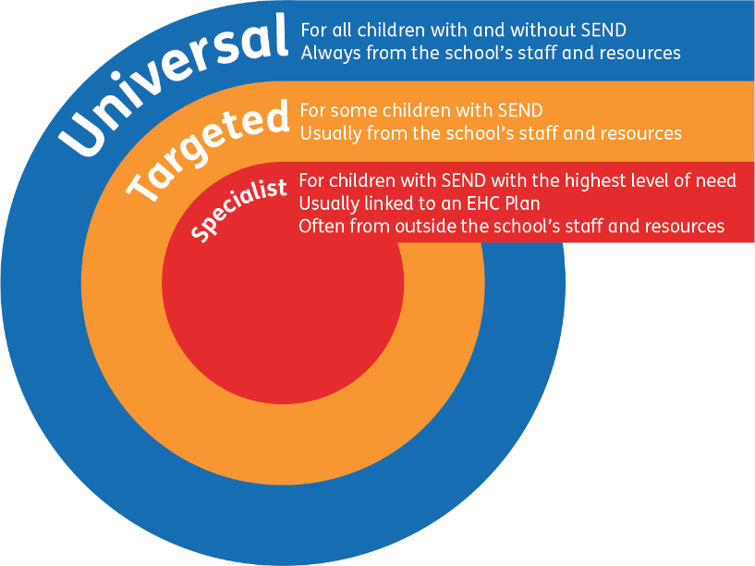

**Universal provision** comprises high quality teaching that is made available to all. This includes strategies, resources and adaptations to the curriculum and environment that teaching staff use to remove barriers to learning for children.

At Swallownest, we firmly believe that ‘*What is essential for one, is good for all’* thus reasonable adjustments for individual needs are made to ensure our school is communication-friendly and sensory-friendly for all pupils.

Our **Universal provision** includes

* A broad, balanced and relevant curriculum with high engagement of pupils, ensuring all pupils are able to access it, for example by grouping pupils, 1:1 work, adapting teaching style, content of the lesson, using alternative ways of recording work etc
* High quality teaching that is differentiated and personalised, for example, giving longer processing times, pre-teaching of key vocabulary, reading instructions aloud, visual instructions etc.
* High expectations of every pupil
* Ambitious targets based on appropriate assessment and dialogue with pupils and parents
* Potential areas of difficulty addressed and potential barriers to learning removed through the effective deployment of resources, adapting our resources and staffing to suit the needs of the class
* Regular assessment, monitoring and review of children and young people’s development and progress

‘*The benefits of early identification are widely recognised – identifying need at the earliest point, and then making effective provision, improves long-term outcomes for children*.’

(Department for Education, 2014, 5.4, SEND Code of Practice: 0-25 years)

High quality universal teaching should reduce the need for extra support for all children. Nevertheless, it is likely that in order to make progress with their learning, behaviour or development some will require additional support in the form of carefully selected, targeted support and interventions. This will have been identified through the assessment process.

These targets will be added to a Support Plan (also known as an Individual Education Plan or IEP). This is known as **Targeted provision, or SEN Support** and will be reviewed on a termly basis.

Some children and young people with more complex and significant needs may require specialist support or services to supplement what the school or setting can ordinarily offer. This is known as **Specialist provision**.

Specialist support does not need to be delivered in a specialist setting. Many children and young people access specialist support in their mainstream setting.

The majority of children and young people with SEN or disabilities will have their needs met within school. Some children and young people may require an EHC needs assessment in order for the local authority to decide whether it is necessary for it to make provision in accordance with an Education Health Care (EHC) plan.

The purpose of an EHC plan is to make special educational provision to meet the special educational needs of the child or young person, to secure the best possible outcomes for them across education, health and social care and, as they get older, prepare them for adulthood.

To achieve this, local authorities use the information from the assessment to:

* establish and record the views, interests and aspirations of the parents and child or young person
* provide a full description of the child or young person’s special educational needs and any health and social care needs
* establish outcomes across education, health and social care based on the child or young person’s needs and aspirations
* specify the provision required and how education, health and care services will work together to meet the child or young person’s needs and support the achievement of the agreed outcomes

1. **APDR- Assess, Plan, Do, Review**

‘*The special educational provision made for a child should always be based on an understanding of their particular strengths and needs and should seek to address them all, using well-evidenced interventions targeted at areas of difficulty and, where necessary, specialist equipment or software*.’

Department for Education, 2014, 5.34, SEND Code of Practice: 0-25 years

Underpinning all our provision in school is the cycle of:

**Assess**: Data on the child held by the school will be collated by the class teacher, the Headteacher and the SENDCo in order to make an accurate assessment of the child’s needs.

**Plan**: If review of the action taken indicates that “*additional to and different from*” support will be required, then the views of all involved, including the parents/carers and the child, will be obtained and appropriate evidence-based interventions identified, recorded and implemented by the teaching team, with advice from the SENDCo. This will be recorded on an individualised Support Plan document, which is shared with the child’s key adults.

**Do**: The targets recorded on the Support Plan will identify a clear set of expected outcomes, which will include challenging and relevant academic and developmental targets. Staff in school will work on these targets with the child.

**Review**: Progress towards the outcomes will be tracked and reviewed termly with the parents/carers and the child. Key adults will be invited to a Review Meeting, where progress and further targets can be discussed and decided.

When a student is displaying a higher level of need, the SENDCo and the school draw on specialised assessments and support from external agencies and professionals, for example, CAMHS (Child & Adolescent Mental Health Services), Aspire Outreach (SEMH), Educational Psychologist Services, Hearing Impairment Service, SIT (Specialist Inclusion Team), Visually Impairment Service and Speech and Language Therapy services, among other relevant agencies.

‘*The views of the pupil should be included in these discussions. This could be through involving the pupil in all or part of the discussion itself, or gathering their views as part of the preparation*.’

(Department for Education, 2014, 6.70, SEND Code of Practice: 0-25 years)

Both pupil voice and parent voice are vital in developing the Support Plan document. The children who have a Support Plan are asked to contribute to their targets and any concerns are addressed. If children find it difficult to verbally communicate their views, staff will attempt to find another method of communication.

1. **How do we communicate with parents?**

High quality communication with parents is essential in ensuring positive relationships and in helping to understand the needs of all stakeholders. More formal reviews are held for those children who have received a 1:1 intervention. For children who have a Support Plan (an Individual Education Plan or IEP), these are reviewed on a termly basis. This meeting involves parents/carers, the child's views, SENDCo and class teacher, as well as outside agencies (where additional support has been provided).

Here at Swallownest Primary School, we aim to work together to identify children with SEND needs through:

* termly parents' evenings which are held by appointment for all children
* annual questionnaires which are sent home to parents for their opinion on how well we are doing as a school to support their child
* termly data analysis
* learning walks and work scrutiny
* the use of the Graduated Response and guidance from external professionals and specialists

We will assess each pupil’s current skills and levels of attainment on entry to the school, which will build on previous settings and Key Stages where appropriate. Class teachers will make regular assessments of progress for all pupils. They will identify the children whose progress is significantly slower than that of their peers, those who fail to match or better their previous rate of progress or fail to close the attainment gap between the child and their peers.

This may include progress in areas other than attainment, for example, social, emotional and mental health needs.

All teachers are responsible for every child in their care, including those with SEND.

1. Accessibility

Our main school building was built over 100 years ago. As such the original building has needed to be adapted to provide ease of access for disabled pupils and adults. Our EYFS building is completely accessible, with access ramps available for use in the main school building.

There are newly-built sensory spaces available in both the main school and the separate EYFS building, which have been designed and furnished to support a wide range of sensory needs. As a school, we are willing to invest in resources which prove to be effective in supporting our SEND children.

At differing points in time, it may be that we need to consult fully with the Local Authority and DSAT, health professionals, families and children to ensure that all necessary adaptations are made, so that any disabled child can have full access to the school and can participate fully in the school curriculum including extra-curricular activities.

In summary, adaptations/facilities currently in place include:

* doorways of sufficient width
* appropriate disabled toilet facilities
* changing facilities
* intimate care equipment to support dignity and independence
* disabled parking in main car park
* adequate lighting in all classrooms
* access ramps in the main school building

The Accessibility Action Plan can also be found on the school’s website.

1. **Admissions arrangements for pupils**

We are always pleased to meet new parents in person and show them around. Please telephone the school office so that we can do everything reasonably possible to meet your child's specific needs. You will always be welcomed! We can also advise you on the application process if needed.

However, please be aware that all admissions are coordinated through the Local Authority. As far as possible, Rotherham's Admissions Team will try to meet parental preferences for schools, but it is not always possible to do so. Places in schools are limited by the physical space in the school.

The Disability Discrimination Act 1995 defines a disabled person as one who has a physical or mental impairment which has a substantial and long-term adverse effect on a person's ability to carry out normal day-to-day activities. Most children with Special Needs will not be disabled within the meaning of the Act.

The admission of pupils with disabilities is considered in the first instance in the same way as non-disabled pupils. Further considerations are made in the light of need and accessibility. It is the school's policy to accommodate pupils with disabilities should parents wish, and individual needs are planned for, to prevent any pupils being treated less favourably than other pupils.

In practice we ensure that classroom and extra-curricular activities encourage the participation of all pupils, including those categorised as having Special Educational Needs. Staff organise human and physical resources within the school to increase access to learning and participation by all pupils.

1. Transition- supporting pupils moving between phases

At Swallownest Primary School, we recognise that times of change can make children feel worried and anxious. Transitions can be particularly difficult for a child with SEND and we take steps to ensure that any transition is as smooth as possible.

We endeavour to support your child as they start with us at school, when they are moving class and when they are leaving to continue their journey at a new school.

**How we do this:**

* Our EYFS teaching staff make contact with pre-school settings and offer Transition sessions in the Foundation Unit prior to the children starting school.
* On entry to F1 and F2, we look to complete a home visit or focused phone call so we can discuss any worries or concerns that you may have about your child starting school.
* In the Summer term before the children move to their next class, time is spent with the new Class Teacher in their new classroom. The teachers involved with the transitioning class will have detailed discussions regarding the strengths and needs of each pupil.
* As your child prepares to move onto secondary education, staff from local secondary schools will visit our setting and the children will have opportunity to visit their future school.
* As part of the Review cycle in the Summer term, the SENDCo from the secondary school will be invited to attend the Y6 SEND Review Meetings to discuss the transitioning pupils with additional needs.

‘*To support transition, the school should share information with the school, college or other setting the child or young person is moving to. Schools should agree with parents and pupils the information to be shared as part of this planning process*.’

Department for Education, 2014, 6.57, SEND Code of Practice: 0-25 years

1. **How does the school support children with medical needs and allergies?**

On diagnosis, or on entry to our school, children with medical needs will be provided with a detailed Individual Health and Care Plan, compiled in partnership with health professionals and parents and if appropriate, the child themselves.

‘*Individual healthcare plans can help to ensure that schools effectively support pupils with medical conditions. They provide clarity about what needs to be done, when and by whom. They will often be essential, such as in cases where conditions fluctuate or where there is a high risk that emergency intervention will be needed*.’

Department for Education, 2014, S15, Supporting pupils at school with medical conditions- Statutory guidance

The school has a policy regarding the administration and managing of medicines. Parents/carers need to contact the school office if prescribed medication is recommended by healthcare professionals and needs to be taken during the school day. A form must also be completed by the parent/carer. All medicines will be handed into and collected from the school office rather than classrooms. On a day-to-day basis, the administrative staff generally oversee the administration of any medications. Any medication must be given to the school office in the packaging that it was dispensed in by the pharmacy, with the child’s name and administration information clearly shown.

As a school, we have regular training and updates on conditions and medication affecting individual children, so that all relevant staff are able to manage medical situations. This includes children who are diagnosed with Diabetes, various allergies and children who are PEG fed on a daily basis. All staff hold First Aid qualifications, which are updated regularly. Staff in the Foundation Stage Unit hold Paediatric First Aid qualifications.

1. **What should you do if you think your child may have Special Educational Needs?**

First of all, talk to us! We pride ourselves on building positive relationships with parents/carers. We always strive to be open and honest with yourselves and hope that you are able to do the same with us.

At Swallownest, we have an open door policy and hope that parents, carers and young people can talk to class teachers, SENDCo or a member of the school leadership team regarding concerns about provision. Your child’s class teacher would be the first person to contact to discuss any concerns about your child’s learning or development.

Parents may also like to seek impartial information and support from Rotherham Special Educational Needs and Disability Information, Advice and Support Service (SENDIASS) [www.rotherhamsendiass.org.uk](http://www.rotherhamsendiass.org.uk/)

Further support for parents of children with SEND can be found through the Rotherham Local Offer website at <https://www.rotherhamsendlocaloffer.org.uk/>

1. **Concerns and Queries**

If you require any additional information about the SEND provision at Swallownest Primary School, or in Rotherham LEA, please contact:

Swallownest Primary School Tel**:** 0114 287 2484

Mrs Leivers (SENDCo): senco@swn.dsat.education

Mr McHale: FAO Mr Mchale [enquiries@swn.dsat.education](mailto:enquiries@swn.dsat.education)

Mrs Peake: FAO Mrs Peake [enquires@swn.dsat.education](mailto:enquires@swn.dsat.education)

All of our SEND information can be found on our school website: <https://swallownestprimary.org/>

Further information can be found on the Rotherham Local Offer Website: [www.rotherhamsendlocaloffer.org.uk](http://www.rotherhamsendlocaloffer.org.uk)

Parents may also like to seek impartial information and support from Rotherham Special Educational Needs and Disability Information, Advice and Support Service (SENDIASS) [www.rotherhamsendiass.org.uk](http://www.rotherhamsendiass.org.uk/) or from the Rotherham Parent Carer Forum <https://www.rpcf.co.uk/> which is a registered charity run by and for families of children and young people (aged 0-25) who have Special Educational Needs and/or Disabilities (SEND).