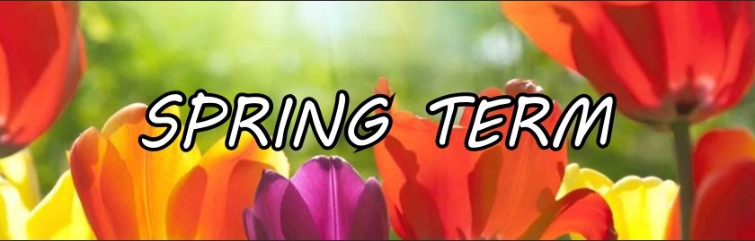

Our Topic is ‘Farms and Growing’

During this half term we will be learning:

|  |  |  |
| --- | --- | --- |
| Maths  We will be learning number bonds to 10, for example 6 and 4 makes 10, 7 and 3 makes 10.  We will also learn to compare numbers up to 10  We will be introduced to subtraction. We will use a part whole model to break apart 10, and find the bonds. For example, 3 less than 10 is 7, 4 less than 10 is 6.  We will also explore patterns. We will look at repeating patterns, then we will create our own repeating patterns. | Phonics  We will continue to recap Phase 2 phonics letters and sounds  We will continue to learn Phase 3 Phonics letters and sounds.  We will learn to segment and blend words, for example c oa t and  sh ee p.  Every child will have a Phonics book to read at school and at home.  Your child has also been given a Bug Club login. You can use this to access more reading books. | English  We will be reading the stories Jack and the Beanstalk, The Little Red Hen and The Three Little Pigs.  We will learn new vocabulary and retell these stories.  We will learn letter formation.  We will be using our Phonics knowledge to write words and phrases. We will continue learn how to write full sentences with a capital letter, finger spaces and a full stop. |
| Science  We will learn about insects and invertebrates. We will also learn about farm animals and how things grow.  We are very excited to go on our school trip to Cannon Hall Farm on Monday 10th March. | Cannon Hall Farm Farm Shop in Barnsley, Yorkshire  What Is Plantation Farming | History  We will be exploring how things have changed in our living history. We will explore toys and look at the similarities and the differences. We will also learn about celebrations as we will be celebrating Easter. |
| Physical Education  We will be learning to use our coordination, footwork and agility to move around the sports hall, We will also use low apparatus to develop our dynamic balance. We will learn the simple effects of excerice and the importance of healthy foods. | ICT  We will be learning to programme a Beebot independently. We will learn the vocabulary forwards, backwards, turn, left and right. We will learn to programme the Beebot to move to a different place on a map. | Design and Technology  We will be learning to join boxes to create an end product. We will read the story Goldilocks and the Three Bears. We will explore a range of chairs, design our own chair, then work in groups to make a chair for Goldilocks or a bear. Then, we will evaluate our design. |

Thank you for all of your continued support. Please continue to read with your child on a regular basis.

We are very excited about our upcoming school trip to Cannon Hall Farm on Monday 10th March. Please bring your child to school at the normal time, we will aim to be on the coach by 9am.