**Quick Recall Facts**

Year 2 – Summer

By the end of this term, children should know these following facts. The aim is for them to know these facts instantly.

**Key Vocabulary**

Twelve **o’clock**

**Half past** two

**Quarter past** three

**Quarter to** nine

Quarter **past** one

Quarter **to** ten

1. **I can tell the time to 15 minutes**.

Children need to be able to tell the time using a clock with hands. This target can be broken down into several steps.

* I can tell the time to the nearest hour.
* I can tell the time to the nearest half hour.
* I can tell the time to the nearest quarter hour.

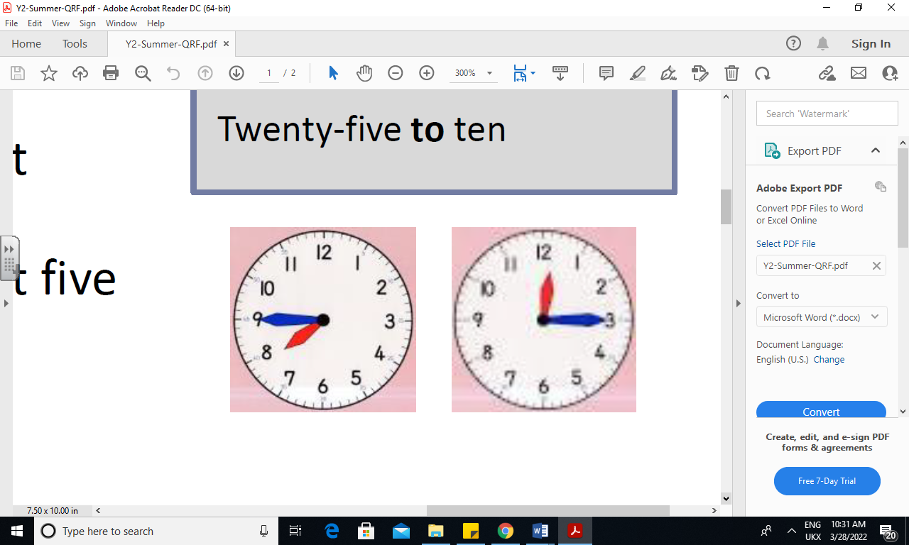

1. **I know my 2, 5 and 10 times table.**

10 x 1 = 10

10 x 2 = 20

10 x 3 = 30

10 x 4 = 40

10 x 5 = 50

10 x 6 = 60

10 x 7 = 70

10 x 8 = 80

10 x 9 = 90

10 x 10 = 100

10 x 11 = 110

10 x 12 = 120

5 x 1 = 5

5 x 2 = 10

5 x 3 = 15

5 x 4 = 20

5 x 5 = 25

5 x 6 = 30

5 x 7 = 35

5 x 8 = 40

5 x 9 = 45

5 x 10 = 50

5 x 11 = 55

5 x 12 = 60

2 x 1 = 2

2 x 2 = 4

2 x 3 = 6

2 x 4 = 8

2 x 5 = 10

2 x 6 = 12

2 x 7 = 14

2 x 8 = 16

2 x 9 = 18

2 x 10 = 20

2 x 11 = 22

2 x 12 = 24

**Key Vocabulary**

What is 2 **multiplied by** 7?

What is 2 **times** 9?

**Top Tips**

The secret is practising little and often. You don’t need to practise these all at once, perhaps you could have a fact of the day. Can you practice these Quick Recall Facts during a car journey?

* Talk about time - Discuss what time things happen. When does your child wake up? What time do they eat breakfast? Make sure that you have an analogue clock visible in your house or that your child wears a watch with hands.
* Ask your child the time regularly – You could also give your child some responsibility for watching the clock: “The cakes need to come out of the oven at quarter past four” or “We need to leave the house at half past eight.
* Songs and Chants–There are lots of songs and chants online. Try: <https://www.youtube.com/watch?v=2sxzxqtnGjA> or <https://www.youtube.com/watch?v=W2NJ_banpqg> Which is your favourite?
* Spot patterns – What patterns can your child spot in the 5 times table? Are there any similarities with the 10 times table?
* Online – Go to <https://www.topmarks.co.uk/maths-games/hit-the-button> for times tables
* Online – Go to <https://www.mathplayground.com/number_bonds_20.html>
* Use memory tricks for those hard-to-remember facts, [www.multiplication.com](http://www.multiplication.com) has some strange picture stories to help children remember. http://www.multiplication.com/learn/learn-fact/2/x/0