Quick Recall Facts
Year 3 – Summer

By the end of this term, children should know these following facts. The aim is for them to know these facts instantly.
Key Vocabulary
Quarter past three
Quarter to nine
Five past one
Twenty-five to ten
Morning, am, afternoon, pm, noon, midnight
- I can tell the time.
Children need to be able to tell the time using a clock with hands. This target can be broken down into several steps.
- I can tell the time to the nearest hour
- I can tell the time to the nearest half hour
- I can tell the time to the nearest quarter hour
- I can tell the time to the nearest five minutes
- I can tell the time to the nearest minute
- I can tell the time using Roman numerals

I know my 8 times table.
8 x 1 = 8
8 x 2 = 16
8 x 3 = 24
8 x 4 = 32
8 x 5 = 40
8 x 6 = 48
8 x 7 = 56
8 x 8 = 64
8 x 9 = 72
8 x 10 = 80
8 x 11 = 88
8 x 12 = 96
8 ÷ 8 = 1
16 ÷ 8 = 2
24 ÷ 8 = 3
32 ÷ 8 = 4
40 ÷ 8 = 5
48 ÷ 8 = 6
56 ÷ 8 = 7
64 ÷ 8 = 8
72 ÷ 8 = 9
80 ÷ 8 = 10
88 ÷ 8 = 11
96 ÷ 8 = 12
Key Vocabulary
What is 8 multiplied by 6?
What is 8 times 4?
What is 32 divided by 4?

Top tips

The secret is practising little and often. You don’t need to practise these all at once, perhaps you could have a fact of the day. Can you practice these Quick Recall Facts while walking to school?

- Talk about time - Discuss what time things happen. When does your child wake up? What time do they eat breakfast? Make sure that you have an analogue clock visible in your house or that your child wears a watch with hands.
- Ask your child the time regularly – You could also give your child some responsibility for watching the clock: “The cakes need to come out of the oven at quarter past four” or “We need to leave the house at half past eight.”

- Online – Go to https://www.topmarks.co.uk for super bowling maths multiplication and Tommy’s Trek

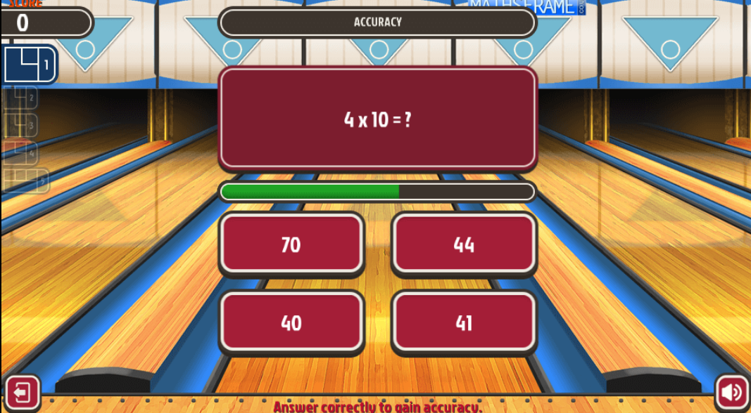
- Songs and Chants – You can buy Times Tables CDs or find multiplication songs and chants online. If your child creates their own song, this can make the times tables even more memorable.
- Double your fours –Multiplying a number by 8 is the same as multiply by 4 and then doubling the answer. 8 × 4 = 32 and double 32 is 64, so 8 × 8= 64.
- Five six seven eight–fifty-six is seven times eight (56 = 7 × 8).

